Beaglebone pinout

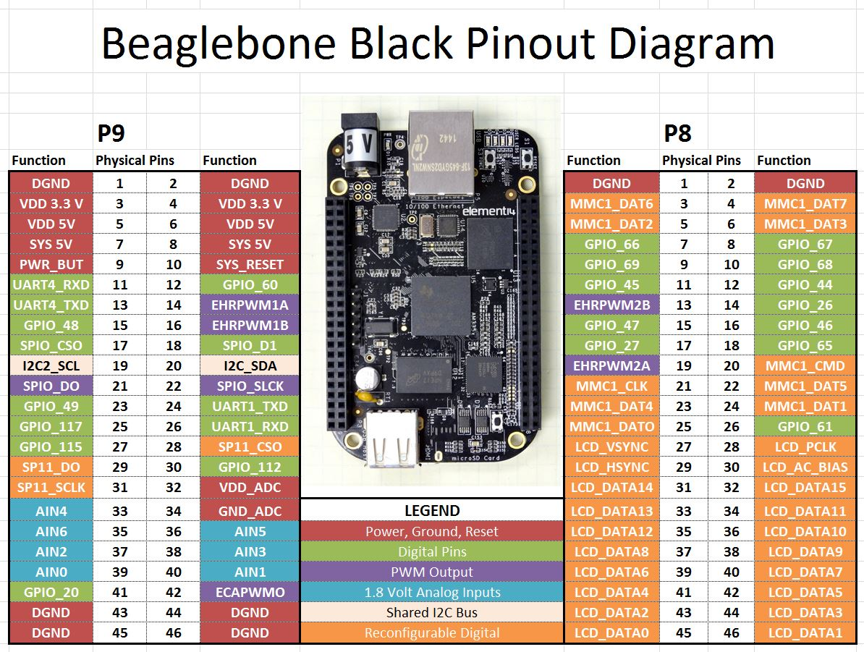

Stepper Motor Driver:

Store page <https://www.pololu.com/product/2134>

Datasheet <https://www.pololu.com/file/0J617/drv8834.pdf>

Stepper Motor

Datasheet <https://www.pololu.com/file/0J635/SY20STH30-0604A.pdf>

Wiring stepper motor to driver board:

**B2 B1 A1 A2 -> black green red blue**

The order doesn’t seem to matter as long as black and green are together and red and blue are together

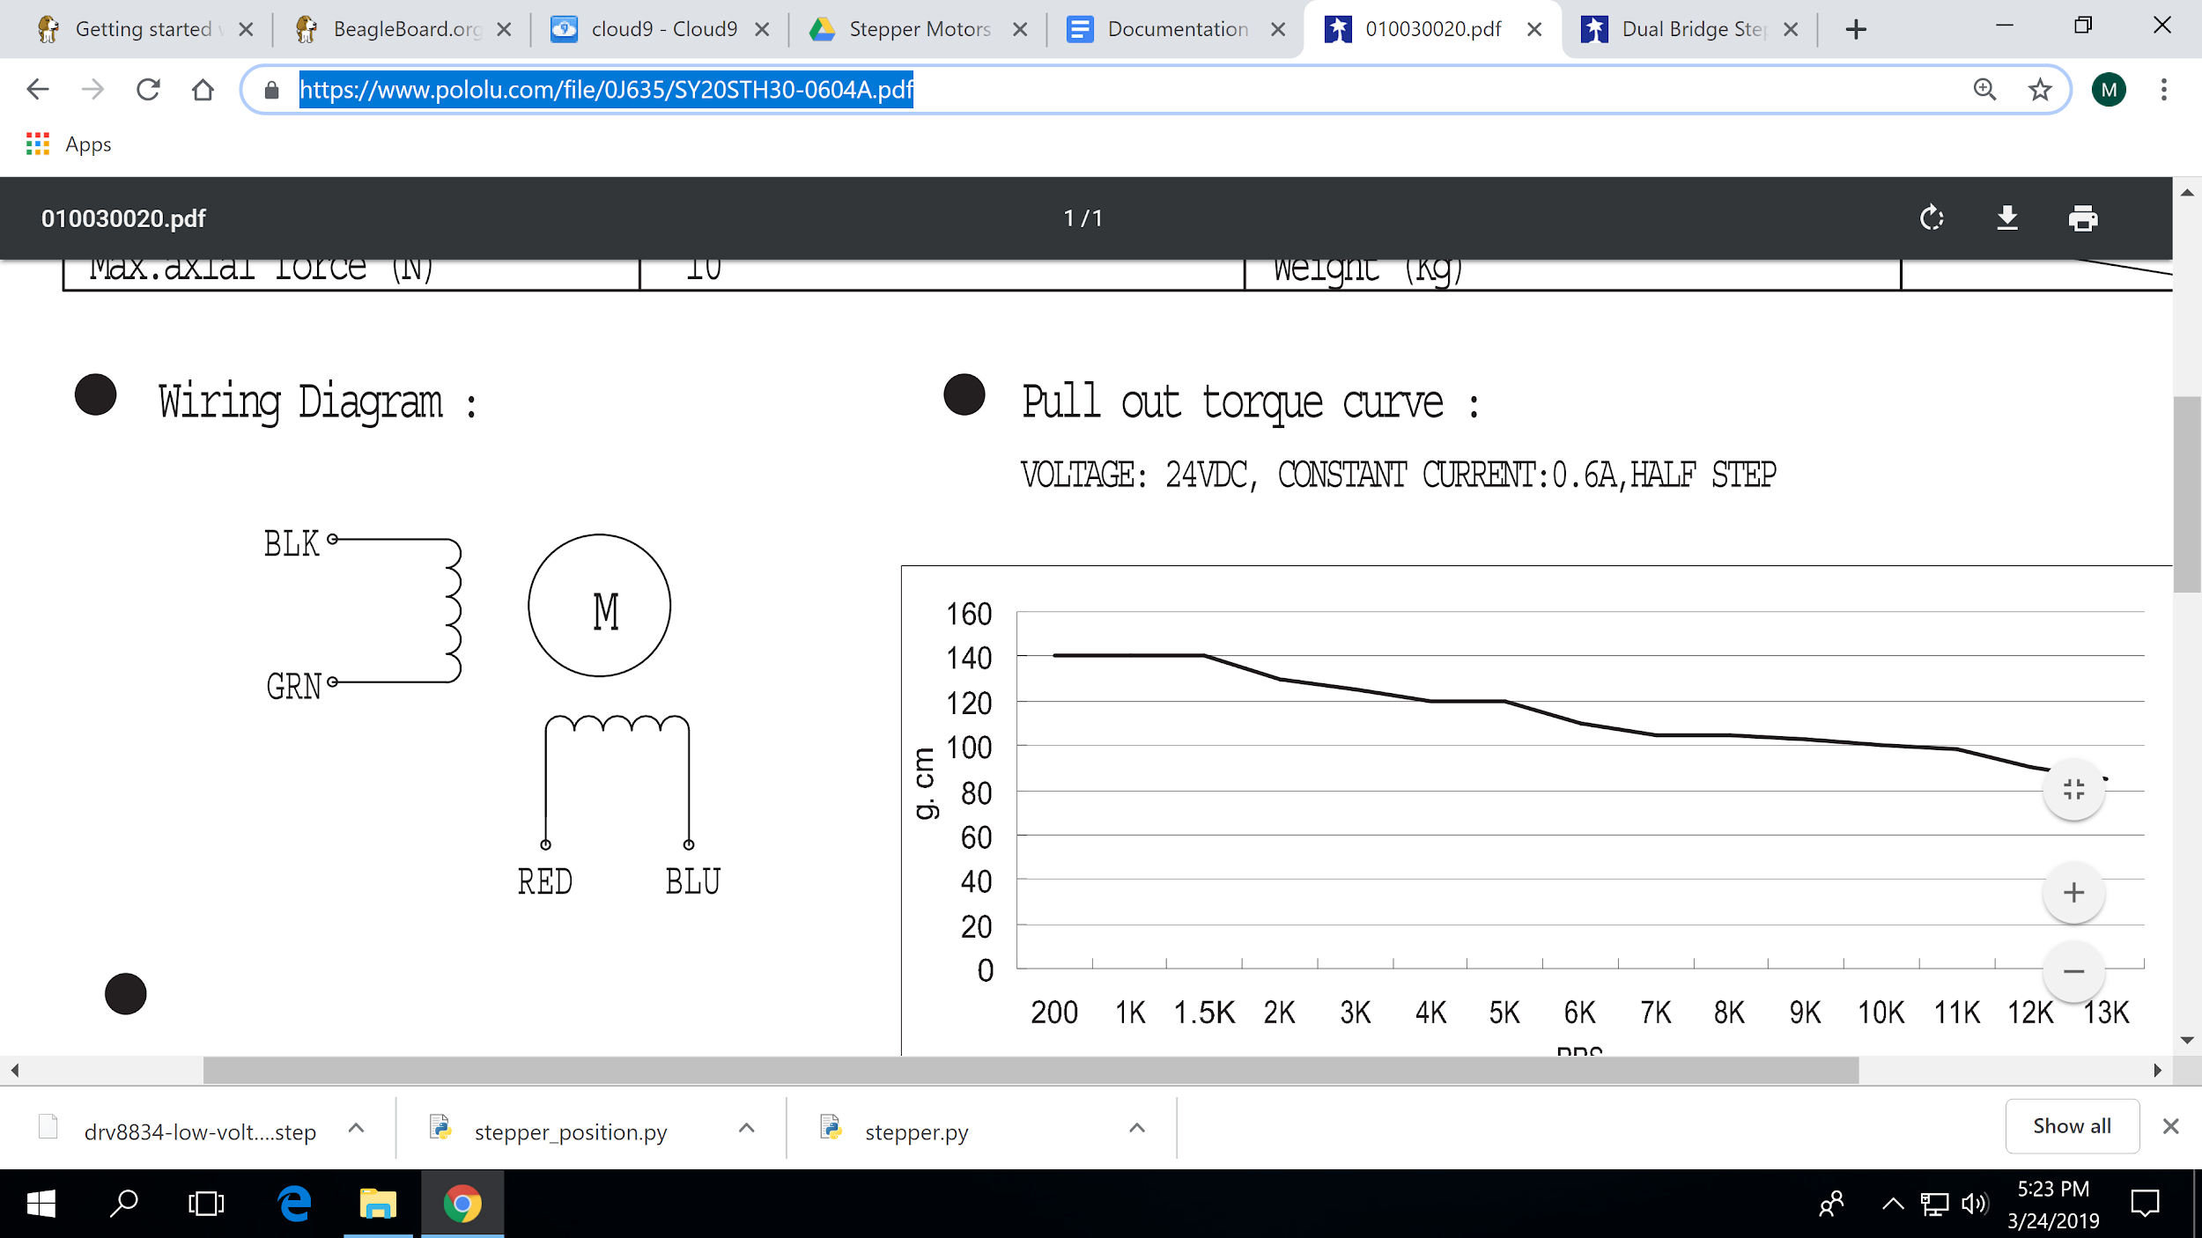

Wiring Stepper 1:

**STEP - P8_7**

**DIR - P8_9**

**SLEEP - SYS_5V**

**VMOT - power supply V_in**

**Both GNDs - GND**

Wiring Stepper 2:

**STEP - P8_8**

**DIR - P8_10**

**SLEEP - SYS_5V**

**VMOT - power supply V_in**

**Both GNDs - GND**

**stepper.py** rotates the stepper motors by user input degrees

Located in the electrical team’s beaglebone /examples/extras/stepper.py and in this drive folder

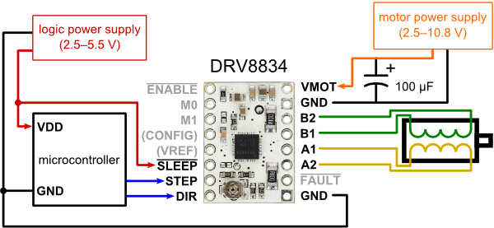**stepper_position.py** rotates the stepper motors to user input degree position

Located in the electrical team’s beaglebone /examples/extras/stepper_position.py and in this drive folder

**stepper_back_forth.js** rotates the stepper motor back and forth

These files are also in the Beaglebone, located in the examples folder

For 17HS16-2004S1, we used stepper 1 connections and 3V